CIS 4911 – Senior Project
Tractouch's iBLESS
User Manual for Guest User

Team Members: Luis Miguel Carrillo
Mentor: Jaime Borras
04/26/2015
COPYRIGHTS AND TRADEMARK INFORMATION

This work is entirely done by Luis Miguel Carrillo unless written otherwise.

Registration Use Case
The guest user types www.ibless.io. Following they are presented with the login screen
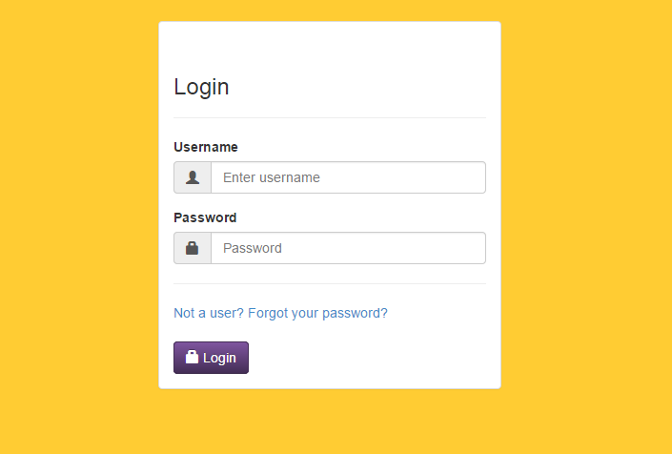

The user clicks on “Not a user?”. They are redirected into the registration screen
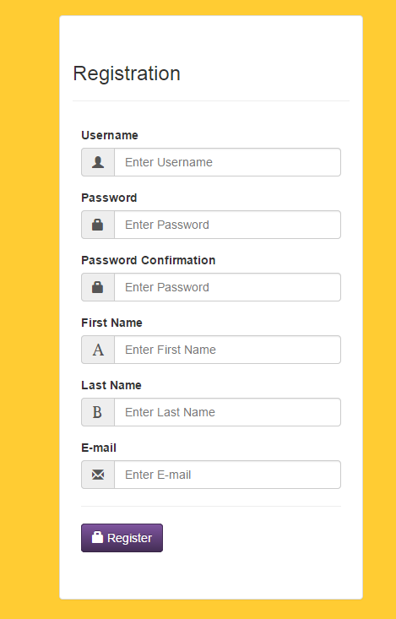

The guest user fills the username, password, password confirmation, first name, last name, and e-mail address. Keep in mind that the username will be used to log in into the system (e-mail can also be used), and that the e-mail will be necessary to recover the password if lost. Finally, the user clicks register and a confirmation message is shown.

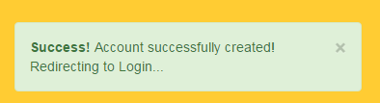

Login Use Case

Now that the user is created, proceed to log in with the credentials used in registration. After logging in the user is presented with their basic information.

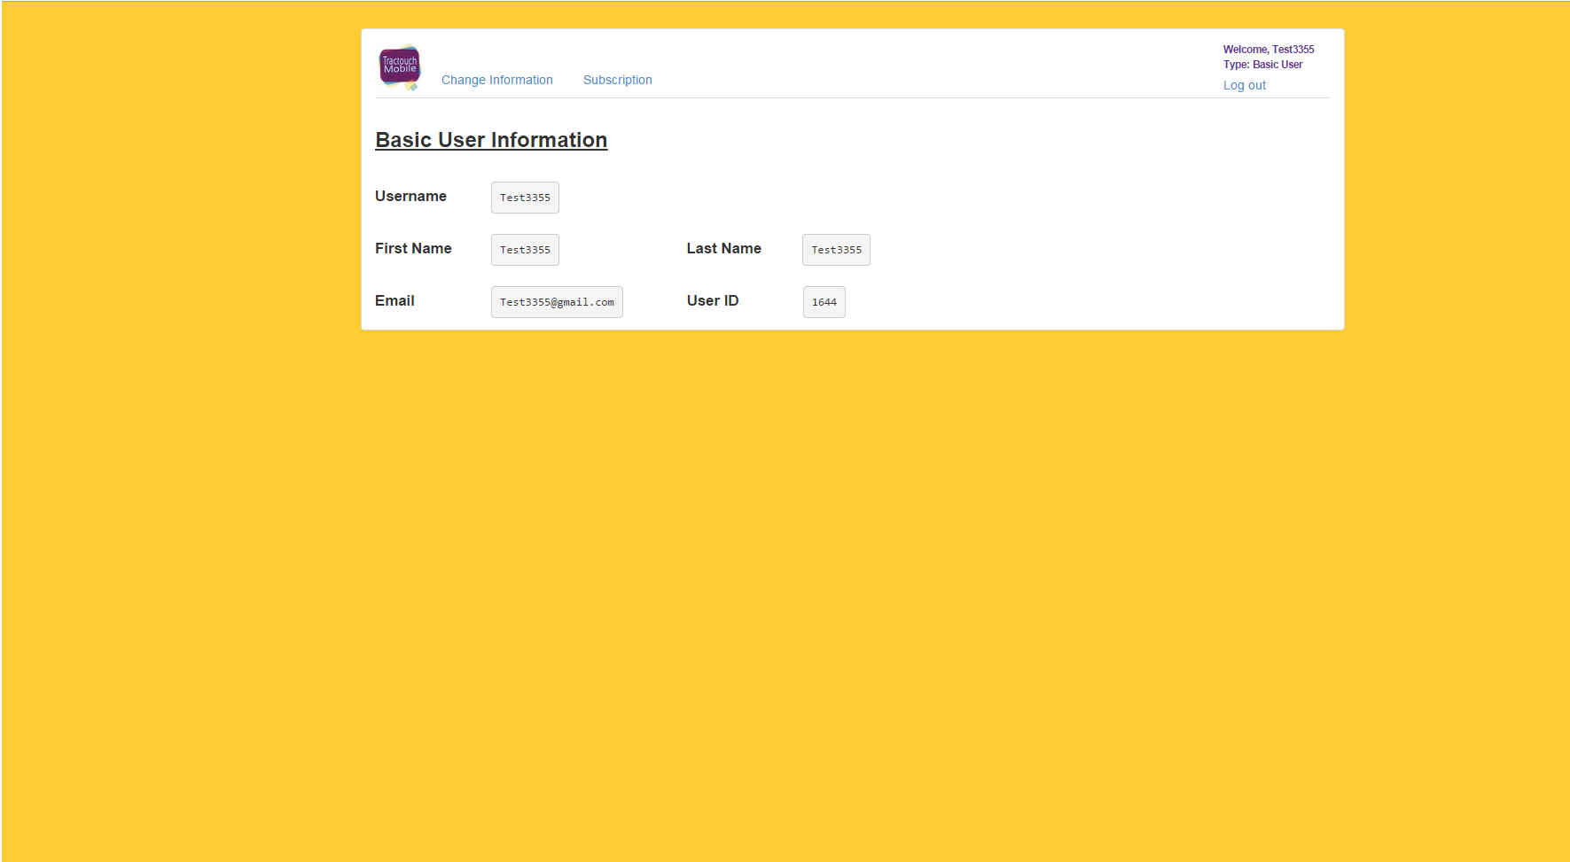
Retrieve Password Use Case

The user can retrieve their password by click on “Forgot your password?” on the Login Screen.

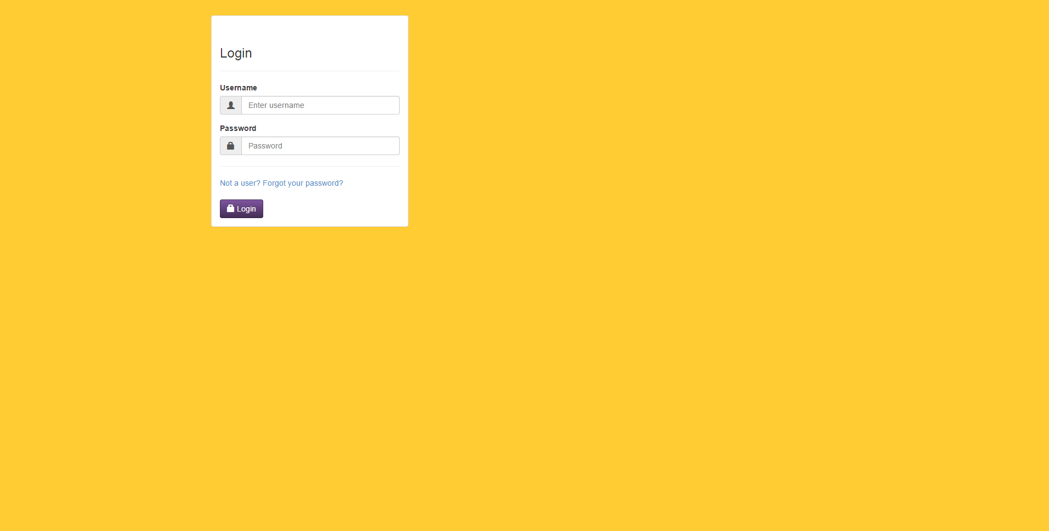
The user will be prompted to enter their e-mail address in order to send an e-mail with instructions on how to recover the lost password.

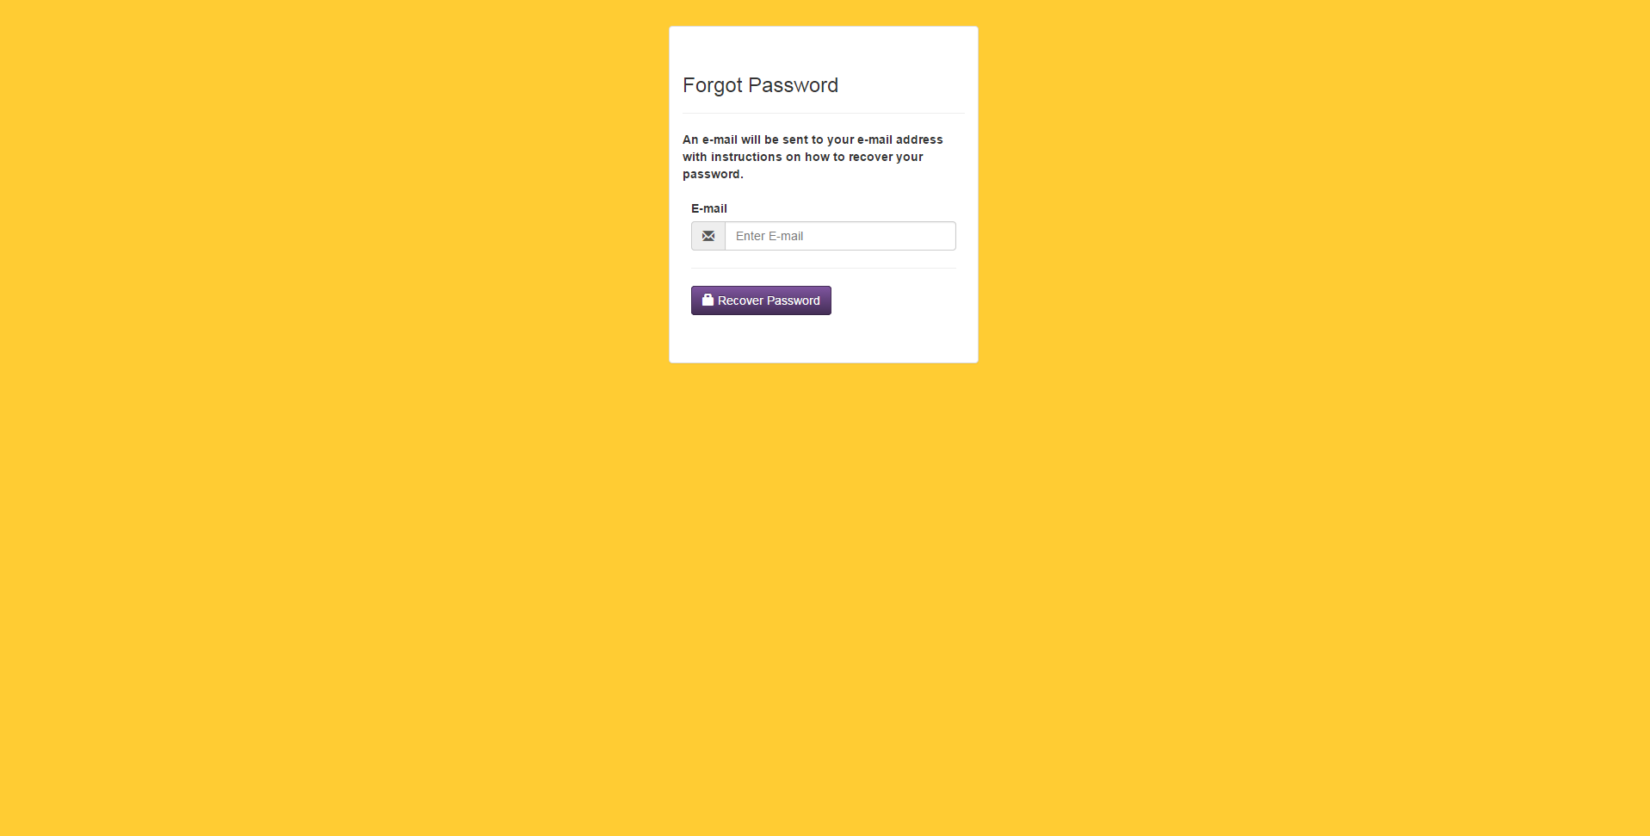
After providing a correct e-mail address, and click recover password, the user will view a notification accepting the request and stating that they will be redirected to login.

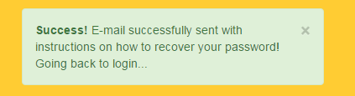

After accessing their e-mail address, an e-mail will be viewable. Click the link to continue.

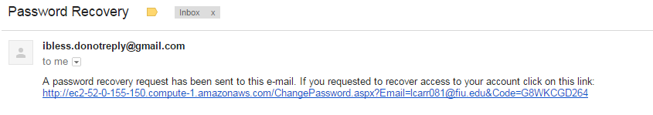

The user will be presented with a screen prompting for a new password.

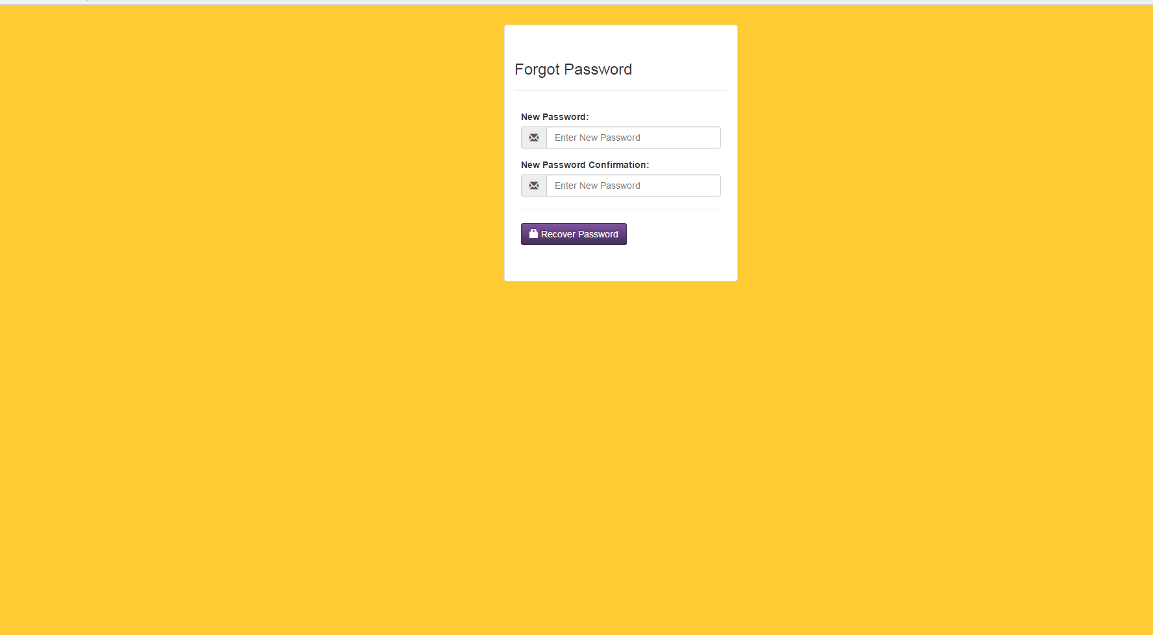
As usual, a confirmation notification will be provided after entering the information.



